#ma'ams prog

a=100

print(a)

b="Rajasree"

print(5\*"\n")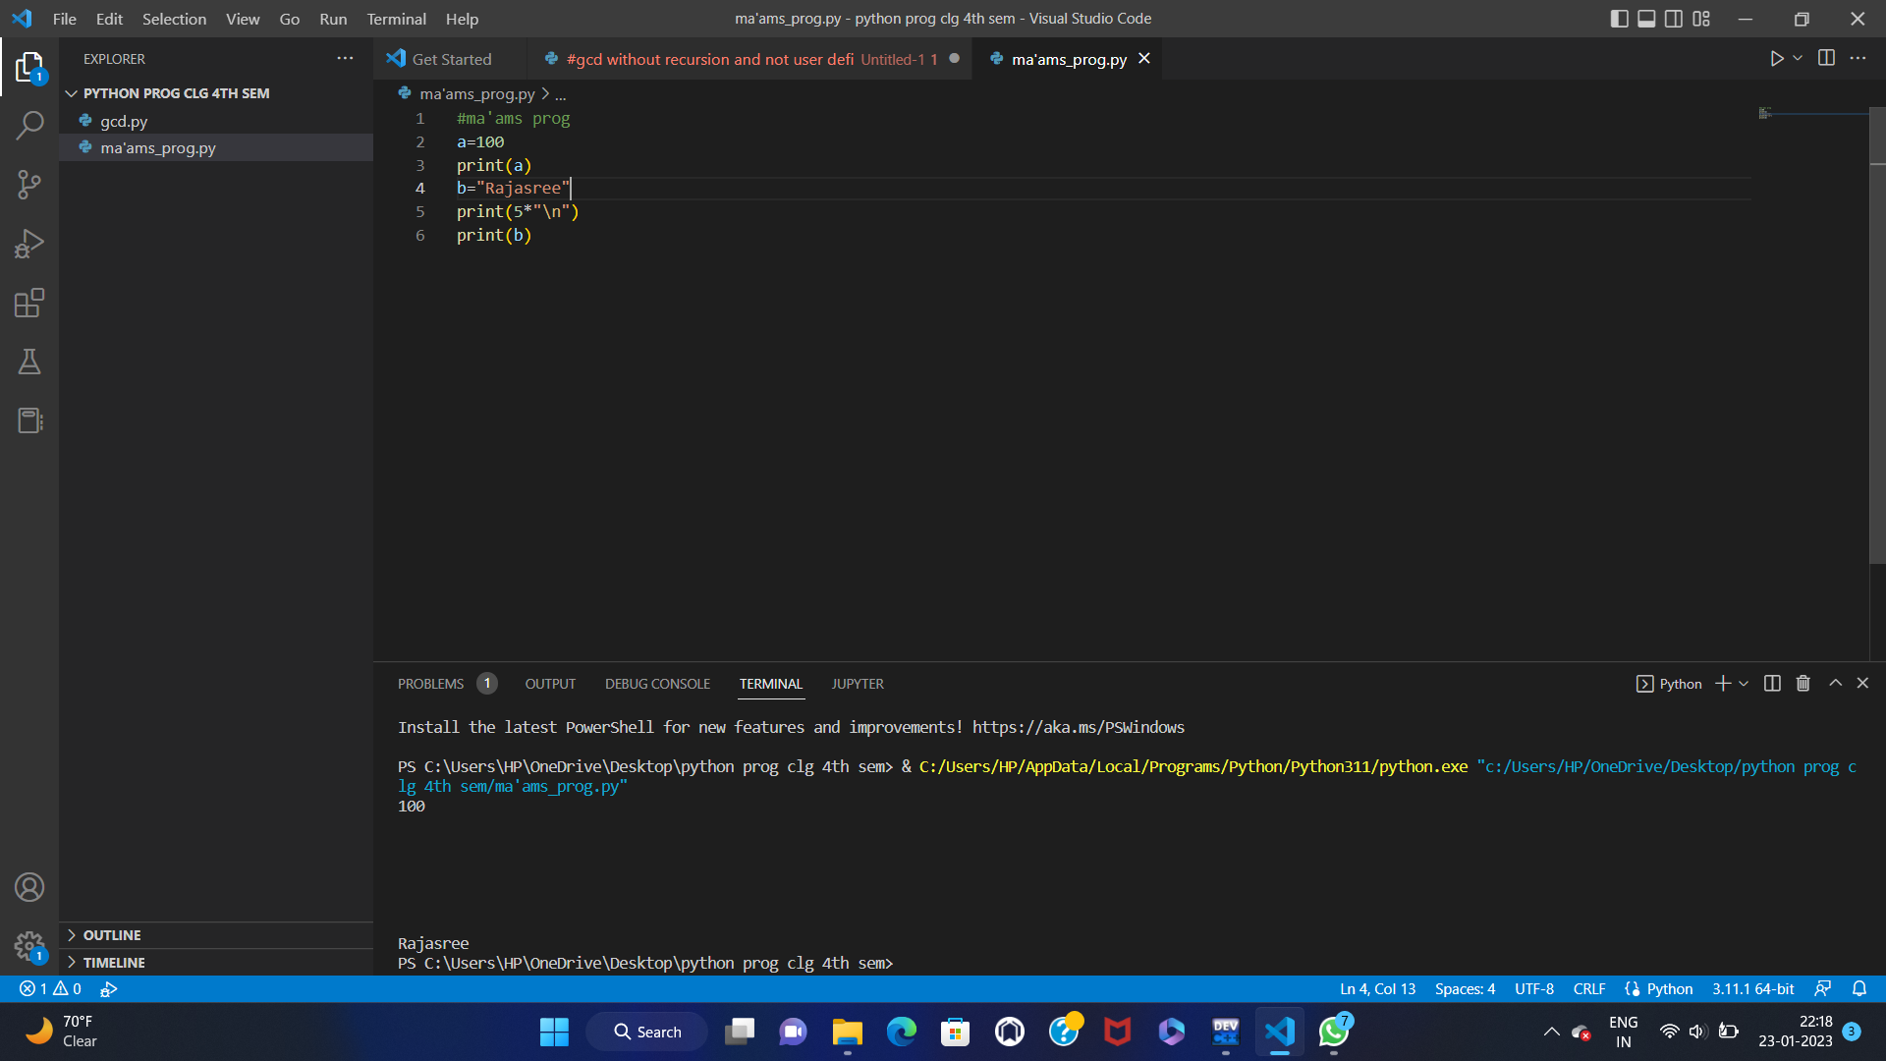

print(b)